**Banyule District Cubs**

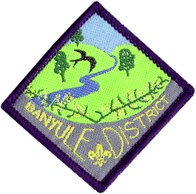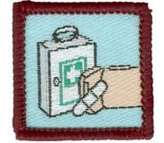**Formerly Red Level 2**

**First Aid Course**

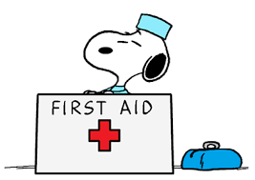

**Saturday 25th May & Sunday 26th May**

**1st Ivanhoe Scout Hall**

**49 Hawker St Ivanhoe**

**Cost**: $30 per Cub (includes 2 lunches and 1 dinner)

Please advise dietary **requirements.**

**Eligibility:** Cubs who haven’t done the course and are due to go up to Scouts

by ***end of June 2025.***

**Equipment:** Full uniform, named water bottle, personal first aid kit

The personal First Aid kit should fit in a small container & this put together by the Cub.

((Akela’s will be provided with list of material.))

This is required for Sunday’s training and testing sessions.

**Saturday**: ***Arrive 10.50*** for an **11-00am start** (need to have time to sign in).

Finish: **7-30pm.**

Cubs will be taking part in training in a wide range of aspects of First Aid.

Of course, we will be having breaks throughout the day for some fun

**Sunday**: ***Arrive 9.15*** for a **9-30am start**.

Finish by **2pm**

First Aid kits, then we will start the testing session.

Cubs are to be paired up and tested across a number of different scenarios where they will treat the ‘victim’ for the problems they find along with a written multiple choice test.

Cubs need to be signed in and***parents to******leave a contact number for both days***

If your Cub is absent for a small part of the weekend, please write on the form the time they will be not be attending.

Return to your Akela (Rosanna Cub Scout Leader) ***at the latest****,* Friday 17th May

Banyule District Cub First Aid Weekend:

Cub Name.............................................. Pack......Rosanna......................

Dietary requirements...............................................................................................................................................................

Will be absent from the Course? (When?).......................................................

***Payment methods:***

Via EFT,

Banking details

Banyule District Cub Scouts

BSB 633 000 ( Bendigo )

A/C 152262291.

Reference: Name, Group & event – e.g. Mary Jones – Rosanna Cubs – First Aid

IF paying by cash - payable on the Saturday

Signed..................................... Phone No...................................

Any questions,

Wayne Renfrew, CSL Rosanna Cubs

Mob: 0411 121 495 Email: akela@rosannacubs.org